# INTERDISCIPLINARY TRAINING REPORT

**AT**

**SATHYABAMA INSTITUTE OF SCIENCE AND TECHNOLOGY**

**(DEEMED TO BE UNIVERSITY)**

Submitted in partial fulfillment of the requirement for the award of Bachelor of Engineering Degree in Computer Science and Engineering

By

## HARRISH KUMAR. L

**(Reg.No. 40110443)**



**DEPARTMENT OF COMPUTER SCIENCE AND ENGINEERING**

**SCHOOL OF COMPUTING**

**SATHYABAMA**

**INSTITUTE OF SCIENCE AND TECHNOLOGY**

### (DEEMED TO BE UNIVERSITY)

**Accredited with Grade “A” by NAAC | 12 B Status**

**by UGC | Approved by AICTE**

**JEPPIAR NAGAR, RAJIV GANDHISALAI,**

**CHENNAI – 600119**

**APRIL 2023**

**SATHYABAMA**

**INSTITUTE OF SCIENCE AND TECHNOLOGY**

### (DEEMED TO BE UNIVERSITY)

**Accredited with Grade “A” by NAAC**

**(Established under Section 3 of UGC Act, 1956)**

**JEPPIAAR NAGAR, RAJIV GANDHI SALAI, CHENNAI– 600119**

**www.sathyabama.ac.in**

# DEPARTMENT OF COMPUTER SCIENCE AND ENGINEERING

**BONAFIDE CERTIFICATE**

This is to certify that this Project Report is the bonafide work of HARRISHKUMAR..L **(40110443)** who carried out the project entitled “ **Age Detection using Image Processing** ” under my supervision from Feb 2023 to Apr 2023.

## Internal Guide

Dr.N.S. USHA, M.E., Ph.D. (Associate professor)

**Head of the Department**

Dr. L. Lakshmanan, M.E., Ph. D

**Submitted for Viva voice Examination held on**

**Internal Examiner External Examiner**

**DECLARATION**

I, **HARRISHKUMAR.L** hereby declare that the Project Report entitled **Age**

**Detection through Image Processing** done by me under the guidance of **Mrs.**

**N.S USHA, M.E., Ph.D (Associate professor)**  (Internal) at **IMARTICUS LEARNING** is submitted in partial fulfillment of the requirements for the award of Bachelor of Engineering degree in Computer Science and Engineering.

## DATE:

## PLACE: SIGNATURE OF THE CANDIDATE

**ACKNOWLEDGEMENT**

I am pleased to acknowledge my sincere thanks to **Board of Management** of **SATHYABAMA** for their kind encouragement in doing this project and for completing it successfully. I am grateful to them.

I convey my thanks to **Dr. T. Sasikala M.E., Ph.D.**, **Dean**, School of Computing., **and Dr.L.Lakshmanan M.E., Ph.D.,** Head of the Department of Computer Science and Engineering for providing me necessary support and details at the right time during the progressive reviews.

I would like to express my gratitude to my Project Guide **Mrs. N.S. Usha M.E., Ph.D.,(Associate professor)** for her valuable guidance, suggestions and constant encouragement paved way for the successful completion of my project work.

I wish to express my thanks to all Teaching and Non-teaching staff members of the **Department of Computer Science and Engineering** who were helpful in many ways for the completion of the project.

TRAINING CERTIFICATE

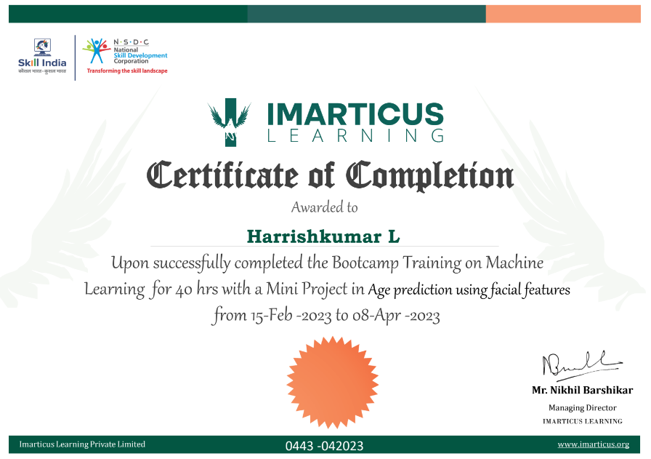

**ABSTRACT**

In this study the working model was proposed and developed to detect age of human faces using image processing. Object detection is a computer technology related to computer vision and image processing that deals with detecting instances of semantic objects of a certain class (such as human faces, cars, fruits, etc.) in digital images and videos. Recently, wide attention has grown in the field of [computer vision](https://www.thepythoncode.com/topic/computer-vision), especially in face recognition, [detection](https://www.thepythoncode.com/article/detect-faces-opencv-python), and facial landmarks localization. Many significant features can be directly derived from the human face, such as age, gender, and emotions.

Age estimation can be defined as the automatic process of classifying the facial image into the exact age or to a specific age range. Basically, age estimation from the face is still a challenging problem, and guessing an exact age from a single image is very difficult due to factors like makeup, lighting, obstructions, and facial expressions.

To build this project we have used basic concept of python, OpenCV, and filetype library.

**OpenCV**: is an open-source library for computer vision, machine learning, and image processing.

**filetype**: is a small and dependency-free Python package to infer file and MIME types.

|  |  |  |
| --- | --- | --- |
| **CHAPTER NO** | **TITLE** | **Pg.No** |
| **1** | **INTRODUCTION** | 8 |
| 1.1 Regression | 8 |
| 1.2 Classification | 9 |
| 1.3 Why Classification is preffered to Regression | 9 |
| 1.4 Face Recognition | 10 |
| 1.5 Age Detection | 10 |
| **2** | **AIM AND SCOPE OF PRESENT INVESTIGATION** |  |
| 2.1 Aim | 11 |
| 2.2 Scope | 11 |
| 2.3 Ideation Map | 12 |
| **3** | **EXPERIMENTAL OR MATERIALS AND METHODS ALGORITHMS USED** |  |
| 3.1 Algorithm | 14 |
| 3.2 Prerequisite | 14 |
| **4** | **RESULT & DISCUSSION** |  |
| 4.1 Result |  |
| 4.2 Source Code |  |
| 4.3 Discussion |  |
| **5** | **CONCLUSION** |  |
| **6** | **REFERENCE** |  |

**LIST OF FIGURES**

|  |  |  |
| --- | --- | --- |
| **No:** | **FIGURE** | **Pg.No** |
| 2.1 | Ideation Map | 12 |
| 2.2 | INSTALL OpenCV | 13 |
| 2.3 | INSTALL os-sys | 13 |
| 2.4 | INSTALL Filetype | 13 |
| 2.5 | INSTALL numpy | 13 |
| 4.1 | OUTPUT | 17 |
| 4.2 | Age Estimation Confusion Matrix | 21 |

**CHAPTER 1**

**INTRODUCTION**

In this project, our goal here is to create a program using python to predict age of a person using live video feed. Pre-trained models are being used for age prediction because the main focus is how to implement the age predictor, using OpenCV.

* 1. **REGRESSION**

Regression is a statistical method used in finance, investing, and other disciplines that attempts to determine the strength and character of the relationship between one dependent variable (usually denoted by Y) and a series of other variables (known as independent variables).

Also called simple regression or ordinary least squares (OLS), linear regression is the most common form of this technique. Linear regression establishes the [linear relationship](https://www.investopedia.com/terms/l/linearrelationship.asp) between two variables based on a [line of best fit](https://www.investopedia.com/terms/l/line-of-best-fit.asp). Linear regression is thus graphically depicted using a straight line with the slope defining how the change in one variable impacts a change in the other. The y-intercept of a linear regression relationship represents the value of one variable when the value of the other is zero.

* 1. **CLASSIFICATION**

Classification is defined as the process of recognition, understanding, and grouping of objects and ideas into preset categories a.k.a “sub-populations.” With the help of these pre-categorized training datasets, classification in machine learning programs leverage a wide range of algorithms to classify future datasets into respective and relevant categories.

Classification algorithms used in machine learning utilize input training data for the purpose of predicting the likelihood or probability that the data that follows will fall into one of the predetermined categories. One of the most common applications of

classification is for filtering emails into “spam” or “non-spam”, as used by today’s top email service providers.

* 1. **CLASSIFICATION IS PREFERRED TO REGRESSION**

Technically, there’s no reason why you can’t treat age prediction as a regression task. There are even some models that do just that. The problem is that age prediction is inherently subjective and based solely on appearance.

**Humans are inherently**bad**at predicting a single age value, we are actually**quite good**at predicting age brackets.** But **people**purposely**try to hide their age.** And if a humanstruggles to accurately predict the age of a person, then surely a machinewill struggle as well.

Once you start treating age prediction as a regression problem, it becomes significantly harder for a model to accurately predict a single value representing that person’s image. However, if you treat it as a classification problem, defining buckets/age brackets for the model, our age predictor model becomes easier to train, often yielding substantially higher accuracy than regression-based prediction alone.

In simple words, **treating age prediction as classification “relaxes” the problem a bit, making it easier to solve — typically, we don’t need the**exact**age of a person; a rough estimate is sufficient.**

**1.4 FACE DETECTION**

Face detection is one of the most widely used computer vision applications. It is a fundamental problem in computer vision and pattern recognition. In the last decade, multiple face feature detection methods have been introduced. In recent years, the

success of deep learning and convolutional neural networks (CNN) have recently shown great results in powering highly-accurate face detection solutions.

Face detection is a computer technology that determines the location and size of a human face in digital images. Given an image, the goal of facial recognition is to determine whether there are any faces and return the bounding box of each detected face (see object detection). Other objects like trees, buildings, and bodies are ignored in the digital image. Face detection can be regarded as a specific case of object-class detection, where the task is finding the location and sizes of all objects in an image that belongs to a given class.

**1.5 AGE PREDICTION**

Age prediction is typically performed using a multivariate set of features derived from one or multiple imaging modalities. A dataset is then specified by including the characteristics of different subjects and their chronological ages. The dataset is employed to train one or more supervised machine learning algorithms which attempt to predict a given subject's brain age by using the brain imaging features while minimizing the difference from the true age and preventing overfitting. Different metrics are commonly used to assess the delta between the predicted age and the actual age of the participants such as Mean Absolute Error.

**CHAPTER 2**

**AIM AND SCOPE OF THE PRESENT INVESTIGATION**

**2.1 AIM**

The aim of this project / study is to develop a tool which can detect age using image processing. The objective of this project is to detect the age of the faces detected in the live feed. This project will be built using the OpenCV library

To build this project we have used basic concept of python, OpenCV, and filetype library. **OpenCV**: is an open-source library for computer vision, machine learning, and image processing. **filetype**: is a small and dependency-free Python package to infer file and MIME types

**2.2 SCOPE OF THIS PROJECT**

The scope of this project is to detect age using image processing. Automatic age classification has become relevant to an increasing amount of applications, particularly since the rise of social platforms and social media. Nevertheless, performance of existing methods on real-world images is still significantly lacking, especially when compared to the tremendous leaps in performance recently reported for the related task of face recognition.

It is very difficult to accurately guess an exact age from a single image because of factors like makeup, lighting, obstructions, and facial expressions. And so, we make this a classification problem instead of making it one of regression.

The major applications are

• Detect faces

• Classify into one of the 8 age ranges

• Put the results on the image and display it

**2.3 IDEATION MAP:**

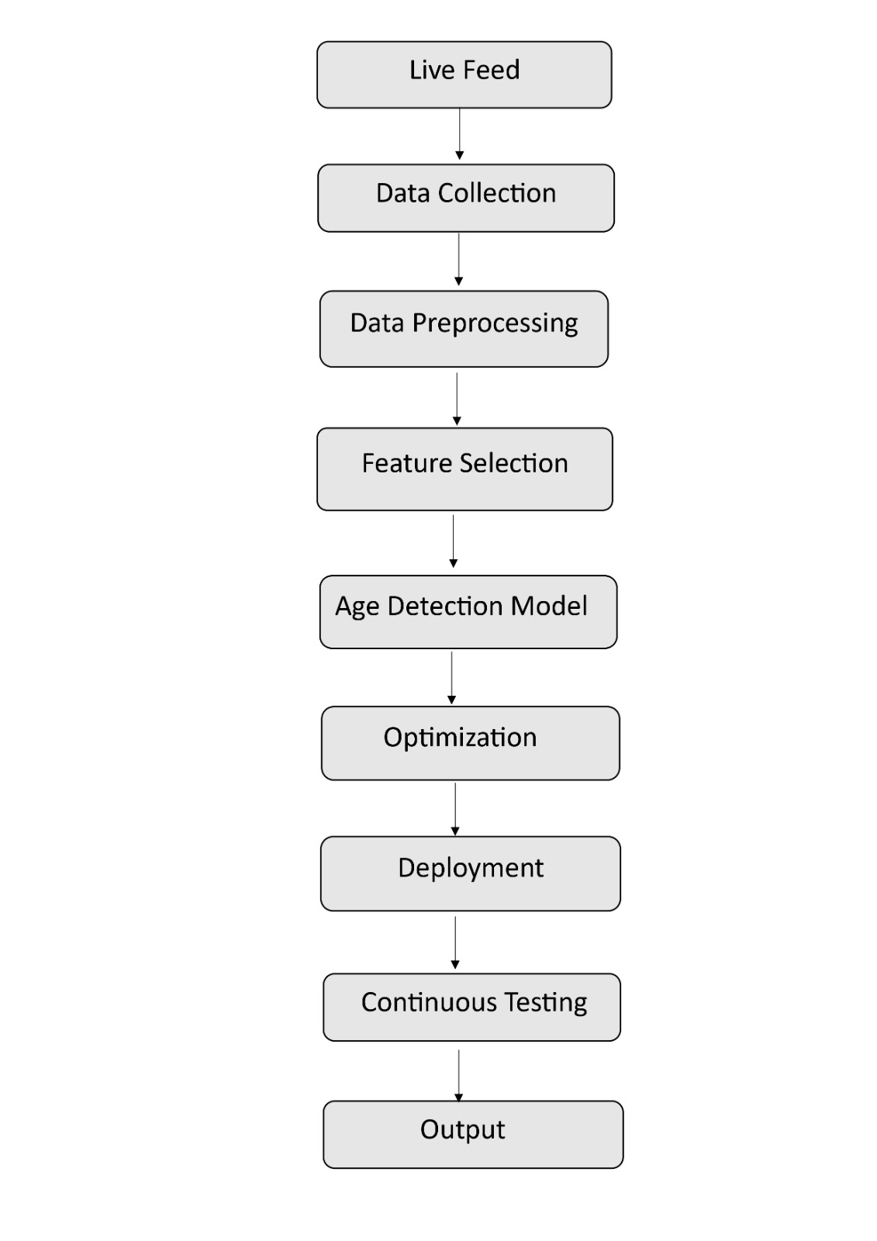

Figure 2.1

INSTALL OpenCV:

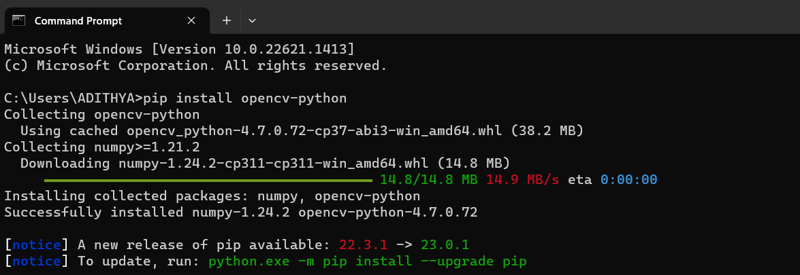

Figure 2.2

INSTALL os-sys:

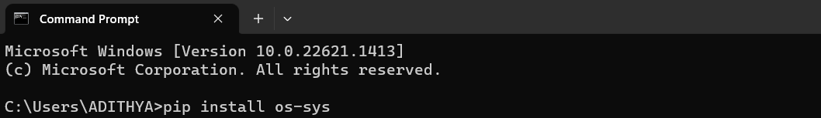

Figure 2.3

INSTALL Filetype:

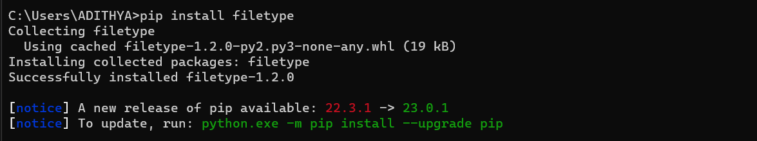

Figure 2.4

INSTALL numpy:

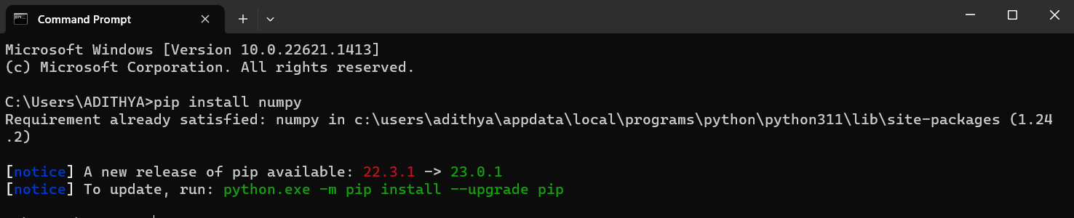

Figure 2.5

**CHAPTER 3**

**EXPERIMENTAL OR MATERIALS AND METHODS ALGORITHMS USED**

**3.1 ALGORITHM**

Age detection is the process of automatically discerning the age of a person solely from a photo of their face.

Typically, age detection is implemented as a two-stage process:

1. **Stage 1:** Detect faces in the input video stream.
2. **Stage 2:** Extract the face Region of Interest (ROI), and apply the age detector algorithm to predict the age of the person.

Given the bounding box (x, y)-coordinates of the face, first extract the face ROI, ignoring the rest of the image/frame. Doing so allows the age detector to focus solely on the person’s face and not any other irrelevant “noise” in the image.

The face ROI is then passed through the model, yielding the actual age prediction.

There are a number of age detector algorithms, but the most popular ones are deep learning-based age detectors — we’ll be using such a deep learning-based age detector.

**3.2 PREREQUISITE**

To develop age detection using image processing the basic concepts of python, OpenCV, and filetype. So the major prerequisite is to install OpenCV and all the other pre-trained models to run the program successfully.

1. **OpenCV:**

**OpenCV** (*Open Source Computer Vision Library*) is a library of programming functions mainly aimed at real-time computer vision. Originally developed by Intel, it was later supported by Willow Garage then Itseez (which was later acquired by Intel). The library is cross-platform and free for use under the open-source Apache 2 License. Starting with 2011, OpenCV features GPU acceleration for real-time operations.

It is the huge open-source library for the computer vision, machine learning, and image processing and now it plays a major role in real-time operation which is very important in today’s systems. By using it, one can process images and videos to identify objects, faces, or even handwriting of a human. When it integrated with various libraries, such as NumPy, python is capable of processing the OpenCV array structure for analysis. To Identify image pattern and its various features we use vector space and perform mathematical operations on these features.

1. **Filetype**

Small and dependency free Python package to infer file type and MIME type checking the magic numbers signature of a file or buffer.

This is a Python port from filetype Go package.

1. **Weights**

For the purpose of this project, pre-trained Caffe models are used, one for face detection, and another model for age detection. Below is the list of necessary files to include in our project directory:

* age_net.caffemodel: It is the pre-trained model weights for age detection.
* deploy_age.prototxt: is the model architecture for the age detection model (a plain text file with a JSON-like structure containing all the neural network layer’s definitions).
* res10_300x300_ssd_iter_140000_fp16.caffemodel: The pre-trained model weights for face detection.
* deploy.prototxt.txt: This is the model architecture for the face detection model.

**CHAPTER 4**

**RESULTS AND DISCUSSION, PERFOMANCE ANALYSIS**

**4.1 RESULTS**

The tool for age detection using image processing was successfully created in Python. The popular OpenCV library has been used for getting the live image feed. The project showed us that age can be predicted without bias with pre-trained image sample models.

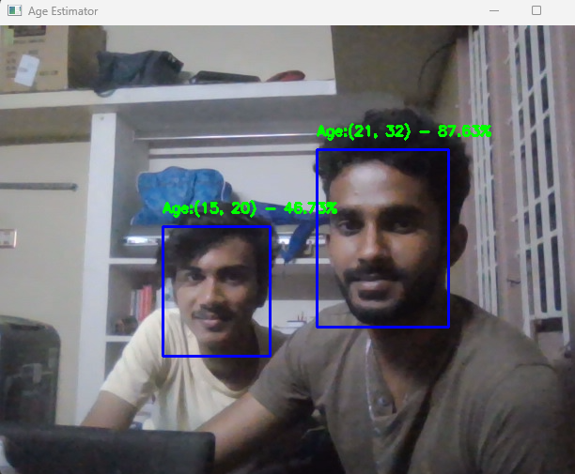

Figure 4.1

In the above image we can see that the code is successfully executed for the age detection purpose. The given input live feed is successfully used by the face detection and age detection models to predict age as output.

**4.2 SOURCE CODE**

import cv2

import os

import filetype

import numpy as np

AGE_MODEL = "weights/deploy_age.prototxt"

AGE_PROTO = "weights/age_net.caffemodel"

MODEL_MEAN_VALUES = (78.4263377603, 87.7689143744, 114.895847746)

AGE_INTERVALS = ['(0, 2)', '(4, 6)', '(8, 12)', '(15, 20)',

                 '(25, 32)', '(38, 43)', '(48, 53)', '(60, 100)']

FACE_PROTO = "weights/deploy.prototxt.txt"

FACE_MODEL = "weights/res10_300x300_ssd_iter_140000_fp16.caffemodel"

frame_width = 1280

frame_height = 720

face_net = cv2.dnn.readNetFromCaffe(FACE_PROTO, FACE_MODEL)

age_net = cv2.dnn.readNetFromCaffe(AGE_MODEL, AGE_PROTO)

def get_faces(frame, confidence_threshold=0.5):

    blob = cv2.dnn.blobFromImage(frame, 1.0, (300, 300), (104, 177.0, 123.0))

    face_net.setInput(blob)

    output = np.squeeze(face_net.forward())

    faces = []

    for i in range(output.shape[0]):

        confidence = output[i, 2]

        if confidence > confidence_threshold:

            box = output[i, 3:7] * np.array([frame.shape[1], frame.shape[0], frame.shape[1], frame.shape[0]])

            start_x, start_y, end_x, end_y = box.astype(np.int64)

            start_x, start_y, end_x, end_y = start_x - \

                                             10, start_y - 10, end_x + 10, end_y + 10

            start_x = 0 if start_x < 0 else start_x

            start_y = 0 if start_y < 0 else start_y

            end_x = 0 if end_x < 0 else end_x

            end_y = 0 if end_y < 0 else end_y

            faces.append((start_x, start_y, end_x, end_y))

    return faces

def get_optimal_font_scale(text, width):

    for scale in reversed(range(0, 60, 1)):

        textSize = cv2.getTextSize(text, fontFace=cv2.FONT_HERSHEY_DUPLEX, fontScale=scale / 10, thickness=1)

        new_width = textSize[0][0]

        if (new_width <= width):

            return scale / 10

    return 1

def image_resize(image, width=None, height=None, inter=cv2.INTER_AREA):

    dim = None

    (h, w) = image.shape[:2]

    if width is None and height is None:

        return image

    if width is None:

        r = height / float(h)

        dim = (int(w * r), height)

    else:

        r = width / float(w)

        dim = (width, int(h * r))

    return cv2.resize(image, dim, interpolation=inter)

def predict_age():

    cap = cv2.VideoCapture(0)

    while True:

        _, img = cap.read()

        frame = img.copy()

        if frame.shape[1] > frame_width:

            frame = image_resize(frame, width=frame_width)

        faces = get_faces(frame)

        for i, (start_x, start_y, end_x, end_y) in enumerate(faces):

            face_img = frame[start_y: end_y, start_x: end_x]

            blob = cv2.dnn.blobFromImage(

                image=face_img, scalefactor=1.0, size=(227, 227),

                mean=MODEL_MEAN_VALUES, swapRB=False

            )

            age_net.setInput(blob)

            age_preds = age_net.forward()

            print("=" * 30, f"Face {i + 1} Prediction Probabilities", "=" * 30)

            for i in range(age_preds[0].shape[0]):

                print(f"{AGE_INTERVALS[i]}: {age_preds[0, i] * 100:.2f}%")

            i = age_preds[0].argmax()

            age = AGE_INTERVALS[i]

            age_confidence_score = age_preds[0][i]

            label = f"Age:{age} - {age_confidence_score * 100:.2f}%"

            print(label)

            yPos = start_y - 15

            while yPos < 15:

                yPos += 15

            cv2.putText(frame, label, (start_x, yPos),

                        cv2.FONT_HERSHEY_SIMPLEX, 0.5, (0, 255, 0), thickness=2)

            cv2.rectangle(frame, (start_x, start_y), (end_x, end_y), color=(255, 0, 0), thickness=2)

        cv2.imshow('Age Estimator', frame)

        if cv2.waitKey(1) == ord("q"):

            break

    cv2.destroyAllWindows()

if __name__ == '__main__':

    predict_age()

**4.3 DISCUSSION**

One of the biggest issues with the age prediction model trained by Levi and Hassner is that it’sheavily biasedtoward the age group 25-32**,** as shown by the following confusion matrix table from [their original publication](https://talhassner.github.io/home/projects/cnn_agegender/CVPR2015_CNN_AgeGenderEstimation.pdf):

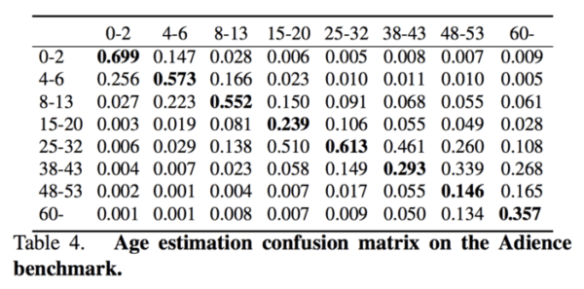

Fig 4.2

That unfortunately means that our model may predict the 25-32 age group when in fact the actual age belongs to a different age bracket — I noticed this a handful of times when gathering results for this tutorial as well as in my own applications of age prediction.

**CHAPTER 5**

**CONCLUSION**

In this project, age detection with OpenCV and Deep Learning was performed.

To do so, a pre-trained model from Levi and Hassner in their 2015 publication, Age and Gender Classification using Convolutional Neural Networks was used. This model allowed us to predict eight different age groups with reasonably high accuracy; however, we must recognize that age prediction is a challenging problem.

There are a number of factors that determine how old a person visually appears, including their lifestyle, work/job, smoking habits, and most importantly, genetics. Secondly, people purposely try to hide their age — if a human struggles to accurately predict someone’s age, then surely a machine learning model will struggle as well.

Therefore, all age prediction results is assessed in terms of perceived age rather than actual age.

**REFERENCE**

**[1]** <https://www.wikipedia.org/>

**[2]** <https://www.google.com/>

**[3]** <https://pyimagesearch.com/>